**Naming**

**Naming services**

* Store collections of <name, attribute>- pairs
* Collection is often subdivided into naming contexts
* Different use cases
  + Identification of an address or attribute for a name (DNS)
  + Identification of a machine for a service (RPC)
  + Identification of a machine for an object (RMI)
* Major operation is to resolve the name to a physical address
* Decouples logical and physical concepts

**DNS: The Domain Name System**

* Cornerstone of the Internet (like a phone book)
* Maps domain names to IP addresses
* Example: www.example.com to IP address of host serving this domain, e.g., 93.184.216.119
* A world-wide distributed database of name servers
* Used by clients (browser, email) to resolve names
* Developed to replace centralized resolution scheme

**Name server / DNS-Server**

* Enables the resolution of domain names
* One primary, multiple secondary name servers for redundancy
* Caches results for repeated requests
* Authoritative name server
  + Is responsible for a domain, each domain has at least one
  + Maintains a list of DNS records in a zone file
* Non-authoritative name server
  + Receives information about domains from other name servers
  + Forwards queries, answers with cached results

**Resolver: DNS-Client**

* A software module able to query a name server
* Interface between application and name server
* Can work **recursively** or **iteratively**

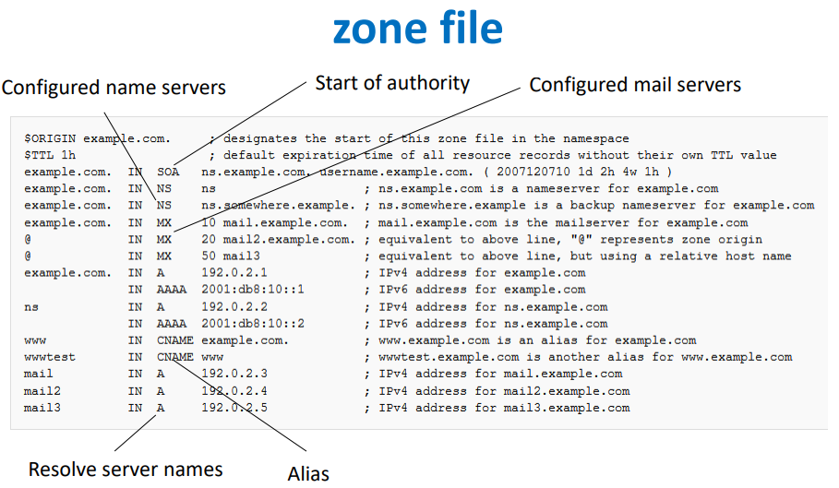

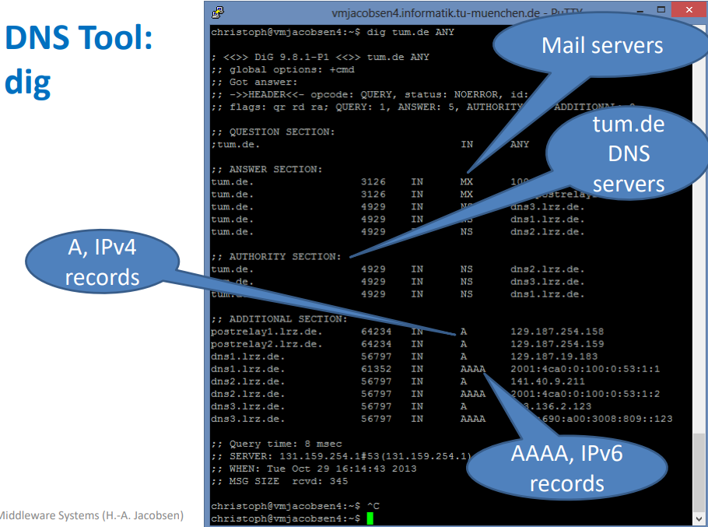

**Name resolution types**

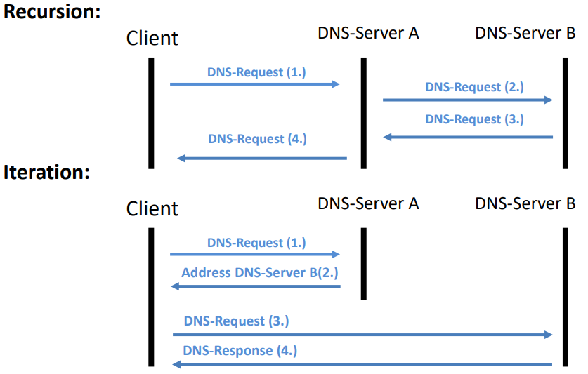

**DNS amplification attack**

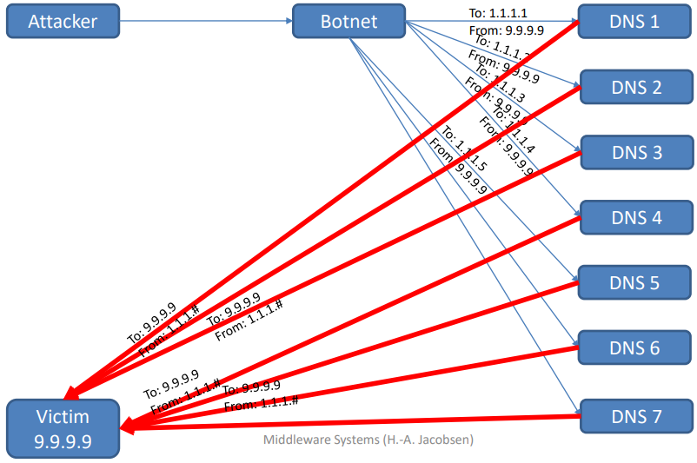

Attacker exploits a flaw in the DNS software to server wrong IP addresses

**Directory Services**

**Directory services**

* Shared information systems infrastructure, similar to a database
* Serve to locate, manage, administer, and organizing networked resources
* For example, data/disk volumes, folders, files, machines, networks, services, devices, printers, users, groups, etc.
* Organization’s personnel, email, phone directory
* Collections of names and multiple attributes
* Names are considered as another attribute
* Look up entries based on (names) attributes and return subsets of attributes

**Comparison to a relational database**

* Directory information is read more often than it is written
* Transactions and rollback are less important
* Data stored redundantly to improve performance
* Distributed and hierarchical organization of servers

Naming Service is called also white pages, i.e. look up phone number by name

* Map<String, Attr>

Directory services is called also yellow pages, i.e. look up phone number by providing attributes

* Map <String, Map<Attr>>

**LDAP**

* Lightweight directory access protocol
* Based on the X.500 standard for directory services
* A common use case of LDAP is “single sign on”

**LDAP overview**

